[LOGO]

**How To Get More**

**5-Star Reviews**

**& Amplify Your Brand**

Presented by: Your Name

**Why You Need Reviews**

|  |  |
| --- | --- |
| **Almost Everyone Reads Reviews**  Before dining or shopping, **93%** of U.S. consumers check online reviews at least some of the time. |  |
| **Reviews Are Trusted**  **72%** of consumers trust online reviews as much as recommendations from friends and family |  |
| **Reviews Are Influential**  **4** out of **5** consumers have reversed a purchase decision based on negative online reviews. |  |
| **Good Reviews Are Under-Represented**  Unhappy customers tell an average of 24 people about their experience. Happy ones tell 15 people. |  |
| **Good Reviews Are Waiting to Happen**  **90%** of typical U.S. consumers read online reviews; **6%** write them |  |

**Reasons Why Happy Customers Don’t Write Reviews**

*“Writing reviews is too tedious”*

*“I forgot to write the review”*

*“I have no time”  
“No one asked me”*

*“I didn’t even think about it”*

*“I don’t know where to write the review”*

**How to Convert More Happy Customers Into Reviewers**

**Step 1.**

Ask them to write a review

**Step 2.**

Make the process easier

**Step 3.**

Follow up with them in a convenient way

**The Reputation Solution:**

**A “Review Funnel”**



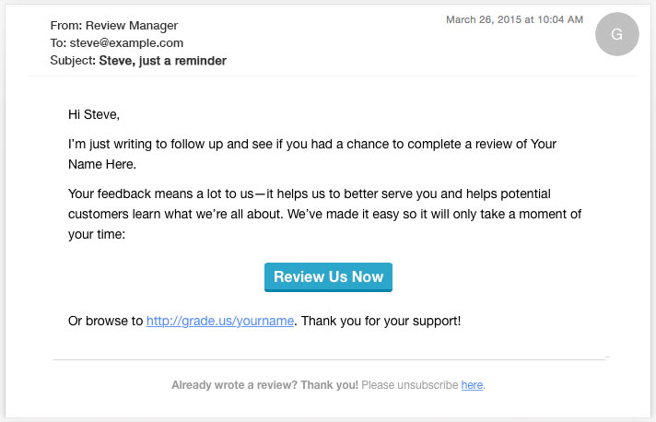

|  |  |
| --- | --- |
| **How a Review Funnel Works** | 1) Ask and remind customers to share their experience online  2) Drive customers to a destination designed to convert them into reviewers  3) Guide each reviewer through selecting the best review site and completing a review |

**Use Multiple Channels To Drive Customers Into The Funnel**

|  |  |
| --- | --- |
| **Email Drip Campaigns**  Automatically email your customer with a drip sequence to encourage reviews! | drip3jpg |
| **Website Widgets**  Put a review widget on your website or thank you page to encourage reviews. |  |
| **Printed “Invites” & Takeaways**  Give customers printed take-aways with your invoices or products to encourage reviews. |  |

**Convert Customers Into Reviewers**

|  |  |
| --- | --- |
| **Step 1: Ask For The Review**  With a easy-to-use clean landing page, we ask a for a review. Here, we pre-qualify the review to make sure it will be positive! | responsive-stars.png |
| **Step 2: Review Site Options**  Next, we present options on where we want the customer to leave a review. | review-funnel.png |
| **Step 3: Review Complete**  The customer selects a site and leaves a review. |  |

**Identify Unhappy Customers Before They Write A Review**

Happy Customers are presented with review site options:

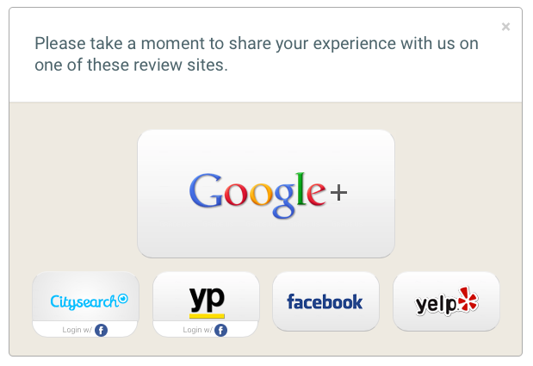

Unhappy Customers are taken to a private form where you can handle the complain privately via email:

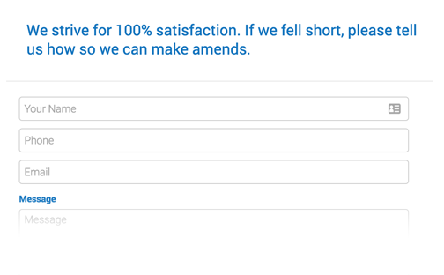

**Monitor & Respond To**

**Reviews & Promote Your Positive Reviews**

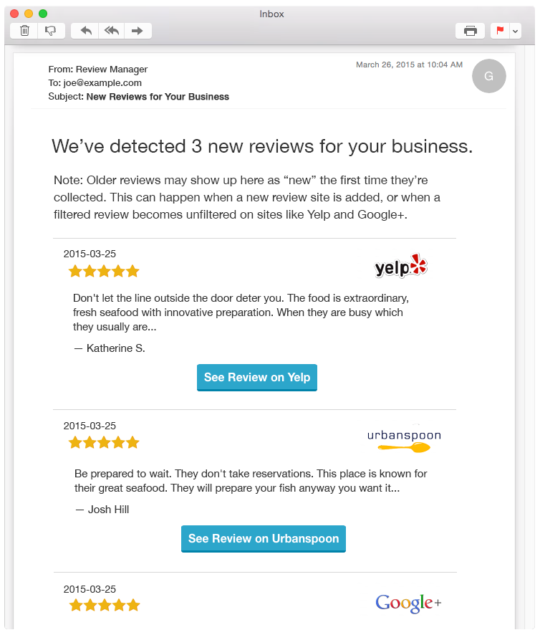

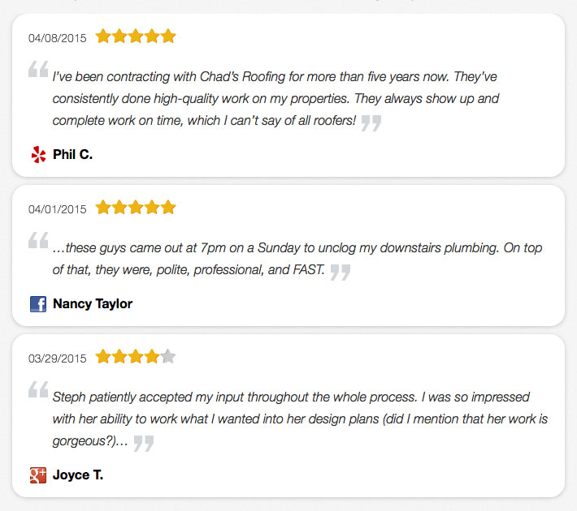

|  |  |
| --- | --- |
| Get email alerts for new reviews. | Display your positive reviews on your website to increase conversions! |

**Awesome Reporting**

**To Track Progress**

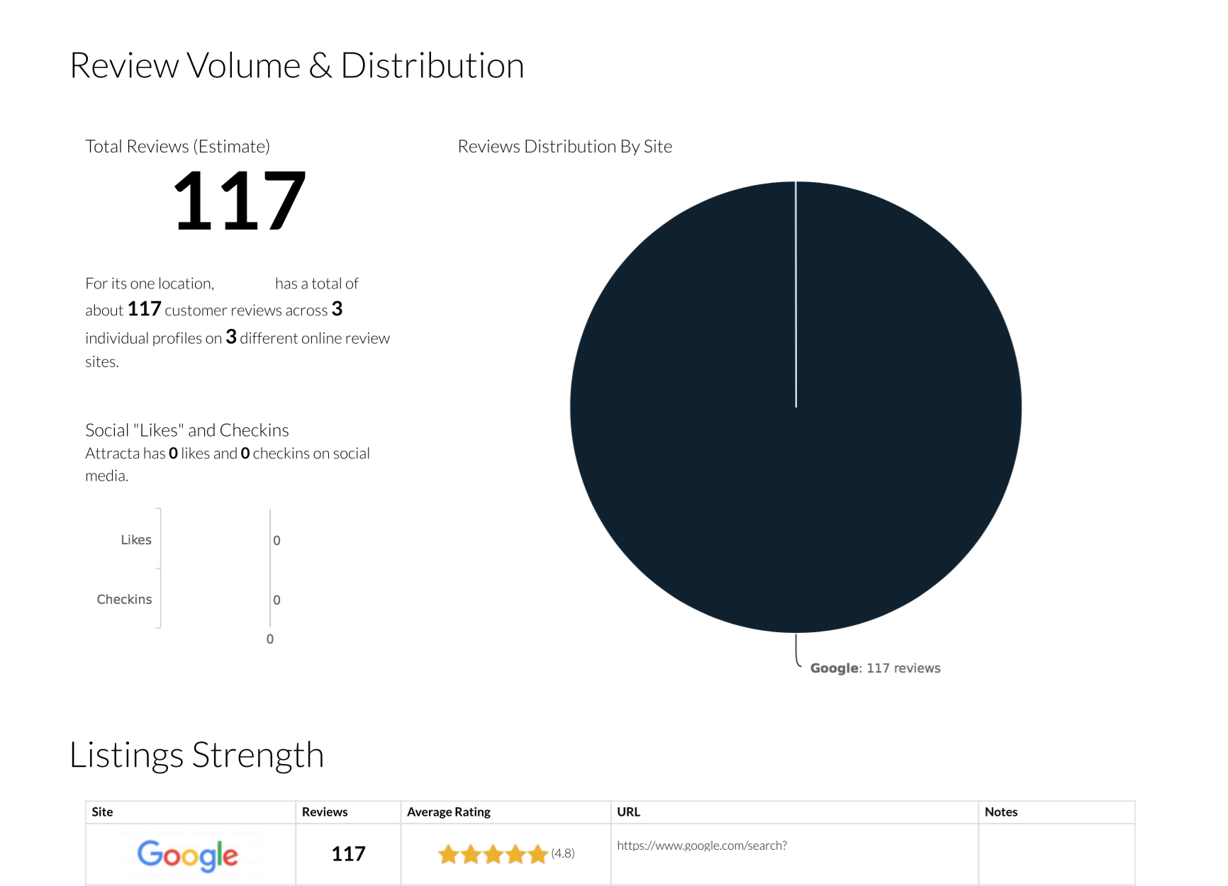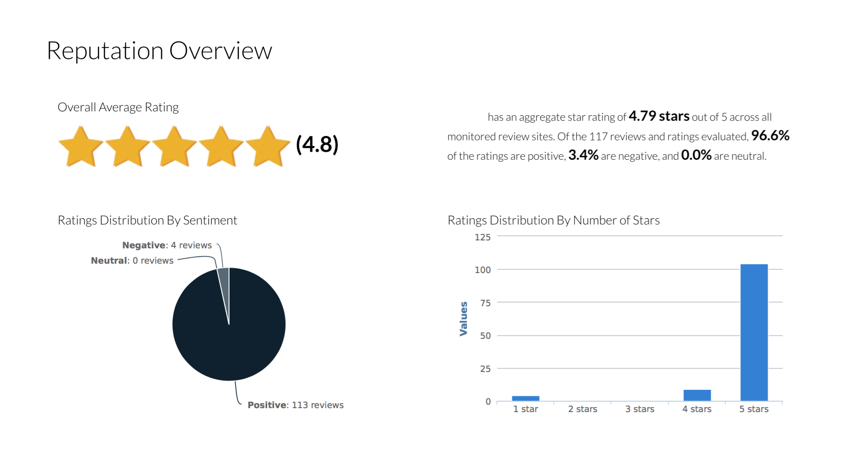

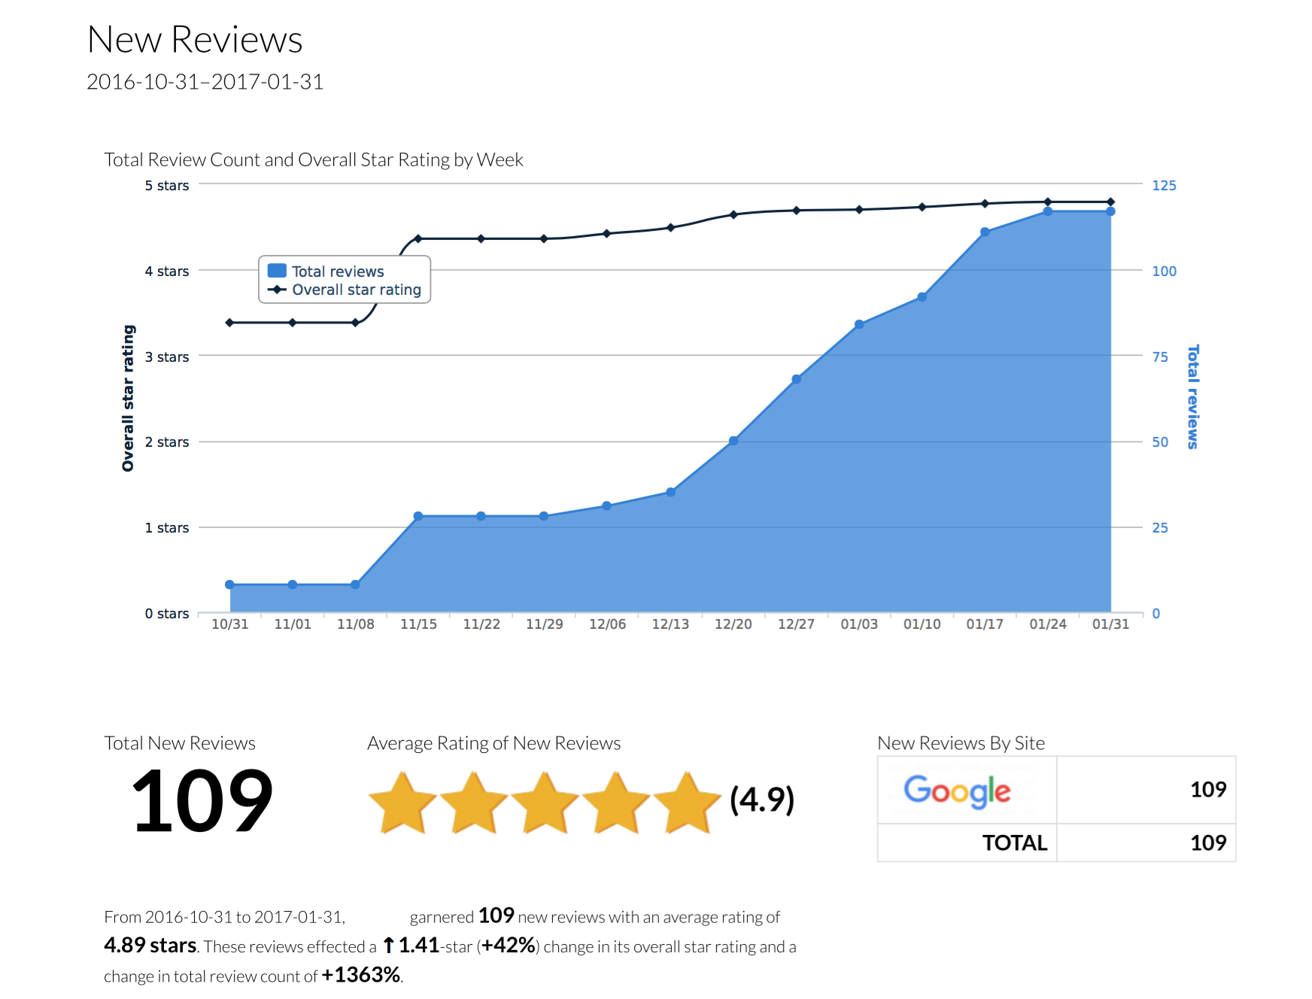

**Unbeatable Features**

|  |  |
| --- | --- |
| **Review Acquisition**  Collect reviews with a customizable landing page  Custom website widget  Email footer widget  Mobile Friendly experience  Generates reviews on major review sites  Industry-specific sites  Collect Reviews On Site | **Review Funnels**  Automated Email Funnels  SMS messaging optional  Printed review invites for offline integration |
| **Review Monitoring**  Sends alerts when new reviews are published  Alerts include review info and link for response  Comprehensively monitors all reviews  Monitors all review sites  Includes major, minor and industry-specific sites | **Review Marketing**  Auto-share positive reviews to social media  Auto-publish reviews to your website  Embeddable rating with rich-snippet markup  Easy Embed Code  Includes aggregate reviews  Custom control over review publishing |
| **Reporting**  PDF and web-based performance/trend reports  Aggregate reports for large, multi-location businesses  Reports sent automatically on any schedule you want | |